Lets upgrade linux

Assignment-1

Task : creating a file named myfile , and open it with vi editor

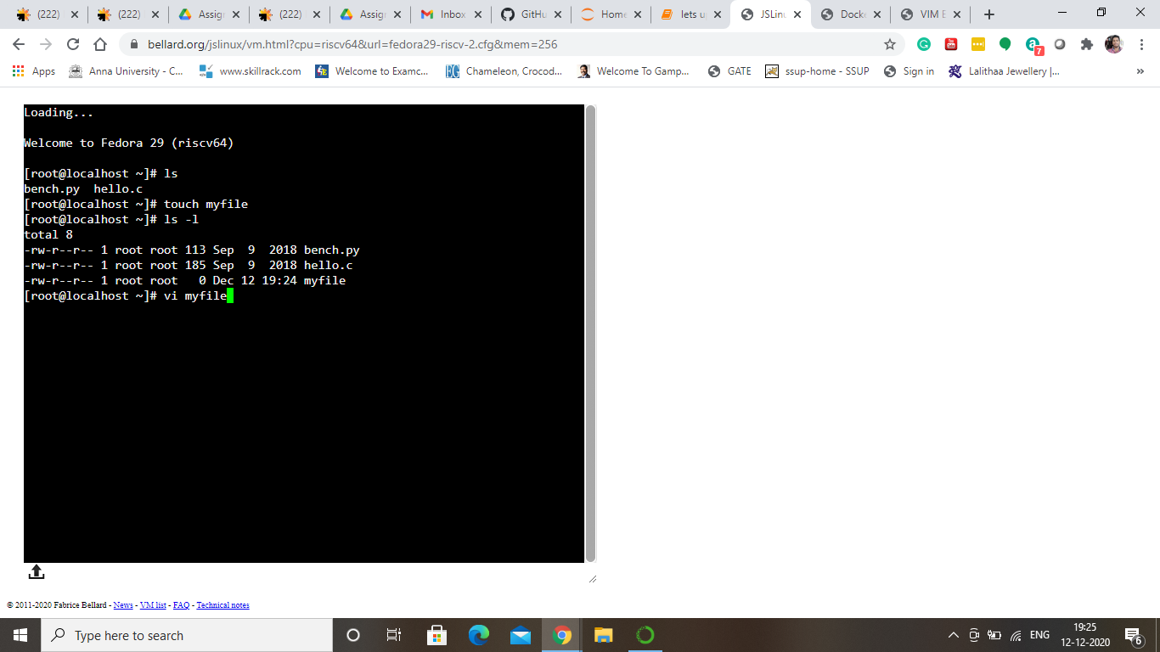

Task : Add your details

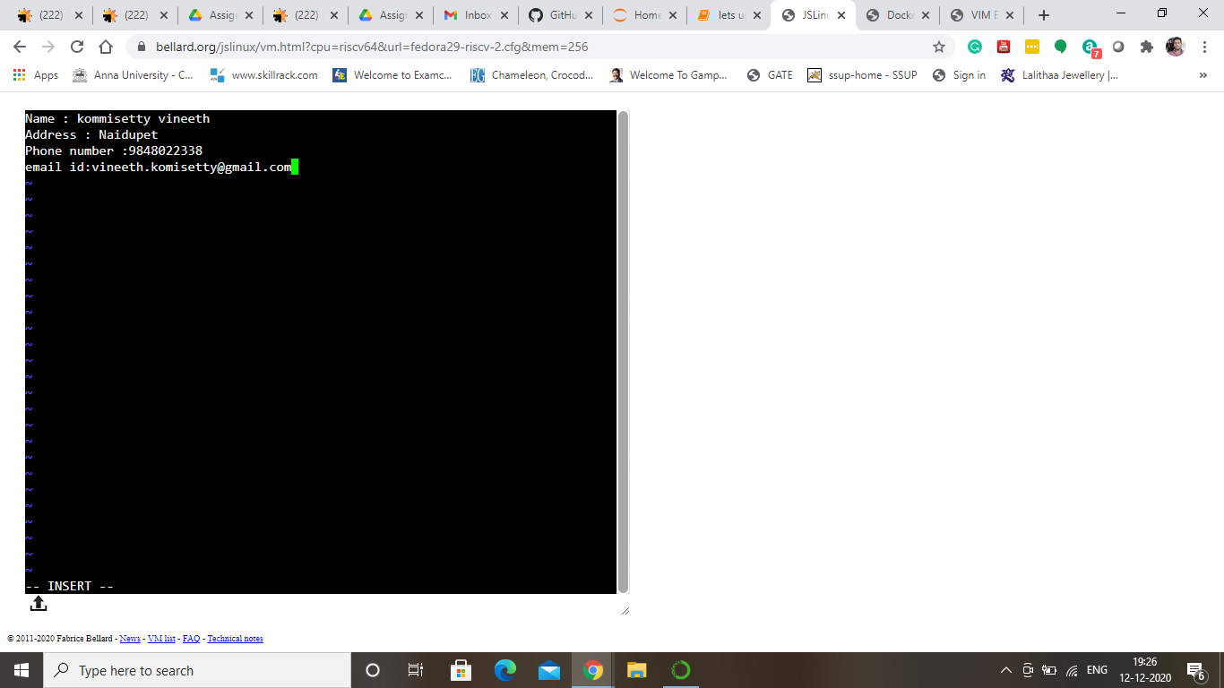

Task :Access the blood group

